Chapter 14
Firms in Competitive Markets
Multiple Choice
1. A market is competitive if
(i) firms have the flexibility to price their own product.
(ii) each buyer is small compared to the market.
(iii) each seller is small compared to the market.
a. (i) and (ii) only
b. (i) and (iii) only
c. (ii) and (iii) only
d. All of the above are correct.
ANSWER: c. (ii) and (iii) only
TYPE: M DIFFICULTY: 2 SECTION: 14.1
2. When a firm has little ability to influence market prices it is said to be in what kind of a market?
a. a competitive market
b. a strategic market
c. a thin market
d. a power market
ANSWER: a. a competitive market
TYPE: M DIFFICULTY: 1 SECTION: 14.1
3. In a competitive market, the actions of any single buyer or seller will
a. have a negligible impact on the market price.
b. have little effect on overall production but will ultimately change final product price.
c. cause a noticeable change in overall production and a change in final product price.
d. adversely affect the profitability of more than one firm in the market.
ANSWER: a. have a negligible impact on the market price.
TYPE: M DIFFICULTY: 2 SECTION: 14.1

Use the information in the table below to answer questions 4 through 7.

Quantity Price
1 13
2 13
3 13
4 13
5 13
6 13
7 13
8 13
9 13
4. The price and quantity relationship in the table is most likely that faced by a firm in a
a. monopoly.
b. concentrated market.
c. competitive market.
d. strategic market.
ANSWER: c. competitive market.
TYPE: M DIFFICULTY: 1 SECTION: 14.1
5. Over which range of output is average revenue equal to price?
a. 1 to 5
b. 3 to 7
c. 5 to 9
d. Average revenue is equal to price over the whole range of output.
ANSWER: d. Average revenue is equal to price over the whole range of output.
TYPE: M DIFFICULTY: 1 SECTION: 14.1
6. Over what range of output is marginal revenue declining?
a. 1 to 6
b. 3 to 7
c. 7 to 9
d. None; marginal revenue is constant over the whole range of output.
ANSWER: d. None; marginal revenue is constant over the whole range of output.
TYPE: M DIFFICULTY: 2 SECTION: 14.1
7. If the firm doubles its output from 3 to 6 units, total revenue will
a. increase by less than $39.
b. increase by exactly $39.
c. increase by more than $39.
d. It cannot be determined from the information provided.
ANSWER: b. increase by exactly $39.
TYPE: M DIFFICULTY: 1 SECTION: 14.1
8. For a firm in a perfectly competitive market, the price of the good is always
a. equal to marginal revenue.
b. equal to total revenue.
c. greater than average revenue.
d. All of the above are correct.
ANSWER: a. equal to marginal revenue.
TYPE: M DIFFICULTY: 1 SECTION: 14.1
9. If a firm in a perfectly competitive market triples the number of units of output sold, then total revenue will
a. more than triple.
b. less than triple.
c. exactly triple.
d. All of the above are potentially true.
ANSWER: c. exactly triple.
TYPE: M DIFFICULTY: 1 SECTION: 14.1
10. Because the goods offered for sale in a competitive market are largely the same,
a. there will be few sellers in the market.
b. there will be few buyers in the market.
c. buyers will have market power.
d. sellers will have little reason to charge less than the going market price.
ANSWER: d. sellers will have little reason to charge less than the going market price.
TYPE: M DIFFICULTY: 1 SECTION: 14.1
11. Which of the following is NOT a characteristic of a perfectly competitive market?
a. Firms are price takers.
b. Firms have difficulty entering the market.
c. There are many sellers in the market.
d. Goods offered for sale are largely the same.
ANSWER: b. Firms have difficulty entering the market.
TYPE: M DIFFICULTY: 1 SECTION: 14.1
12. When buyers in a competitive market take the selling price as given, they are said to be
a. market entrants.
b. monopolists.
c. free riders.
d. price takers.
ANSWER: d. price takers.
TYPE: M DIFFICULTY: 1 SECTION: 14.1
13. When firms are said to be price takers, it implies that if a firm raises its price,
a. buyers will go elsewhere.
b. buyers will pay the higher price in the short run.
c. competitors will also raise their prices.
d. firms in the industry will exercise market power.
ANSWER: a. buyers will go elsewhere.
TYPE: M DIFFICULTY: 1 SECTION: 14.1
14. Which of the following statements best reflects a price-taking firm?
a. If the firm were to charge more than the going price, it would sell none of its goods.
b. The firm has no incentive to charge less than the going price.
c. The firm can sell as much as it wants to sell at the going price.
d. All of the above are correct.
ANSWER: d. All of the above are correct.
TYPE: M DIFFICULTY: 2 SECTION: 14.1
15. In a competitive market, no single producer can influence the market price because
a. many other sellers are offering a product that is essentially identical.
b. consumers have more influence over the market price than producers do.
c. government intervention prevents firms from influencing price.
d. producers agree not to change the price.
ANSWER: a. many other sellers are offering a product that is essentially identical.
TYPE: M DIFFICULTY: 2 SECTION: 14.1
16. A competitive firm might choose to set its price below the market price, because
a. this would result in higher average revenue.
b. this would result in higher profits.
c. this would result in lower total costs.
d. None of the above are correct.
ANSWER: d. None of the above are correct.
TYPE: M DIFFICULTY: 2 SECTION: 14.1
17. Of the following characteristics of competitive markets, which are necessary for firms to be price takers?
(i) There are many sellers.
(ii) Firms can freely enter or exit the market.
(iii) Goods offered for sale are largely the same.
a. (i) and (ii) only
b. (i) and (iii) only
c. (ii) only
d. All are necessary.
ANSWER: b. (i) and (iii) only
TYPE: M DIFFICULTY: 2 SECTION: 14.1
18. When a firm in a competitive market produces 10 units of output, it has a marginal revenue of $8.00. What would be the firm’s total revenue when it produces 6 units of output?
a. $4.80
b. $6.00
c. $48.00
d. $60.00
ANSWER: c. $48.00
TYPE: M DIFFICULTY: 2 SECTION: 14.1
19. When a firm in a competitive market receives $500 in total revenue, it has a marginal revenue of $10. What is the average revenue, and how many units were sold?
a. $5 and 100
b. $10 and 50
c. $10 and 100
d. The answer cannot be determined from the information given.
ANSWER: b. $10 and 50
TYPE: M DIFFICULTY: 2 SECTION: 14.1
20. Starting from a situation in which a firm in a competitive market produces and sells 500 door knobs for a price of $10 per doorknob, which of the following events would decrease the firm’s average revenue?
a. The firm increases its output above 500 doorknobs.
b. The firm decreases its output below 500 doorknobs.
c. The market price of doorknobs rises above $10.
d. The market price of doorknobs falls below $10.
ANSWER: d. The market price of door knobs falls below $10.
TYPE: M DIFFICULTY: 1 SECTION: 14.2
21. Whenever a perfectly competitive firm chooses to change its level of output, holding the price of the product constant, its marginal revenue
a. increases if MR < ATC and decreases if MR > ATC.
b. does not change.
c. increases.
d. decreases.
ANSWER: b. does not change.
TYPE: M DIFFICULTY: 1 SECTION: 14.1
22. If a firm in a competitive market reduces its output by 20 percent, then as a result the price of its output is likely to
a. increase.
b. remain unchanged.
c. decrease by less than 20 percent.
d. decrease by more than 20 percent.
ANSWER: b. remain unchanged.
TYPE: M DIFFICULTY: 1 SECTION: 14.1
23. Changes in the output of a perfectly competitive firm, without any change in the price of the product, will change the firm’s
a. total revenue.
b. marginal revenue.
c. average revenue.
d. All of the above are correct.
ANSWER: a. total revenue.
TYPE: M DIFFICULTY: 2 SECTION: 14.1
24. When a profit-maximizing firm in a competitive market has zero economic profit, accounting profit
a. is negative (accounting losses).
b. is positive.
c. is also zero.
d. could be positive, negative or zero.
ANSWER: b. is positive.
TYPE: M DIFFICULTY: 2 SECTION: 14.1
25. As a general rule, when accountants calculate profit they account for explicit costs but usually ignore
a. certain outlays of money by the firm.
b. implicit costs.
c. operating costs.
d. fixed costs.
ANSWER: b. implicit costs.
TYPE: M DIFFICULTY: 1 SECTION: 14.1
26. In calculating accounting profit, accountants typically don’t include
a. long-run costs.
b. sunk costs.
c. explicit costs of production.
d. opportunity costs that do not involve an outflow of money.
ANSWER: d. opportunity costs that do not involve an outflow of money.
TYPE: M DIFFICULTY: 1 SECTION: 14.1
Use the following information to answer questions 27 through 29.

As part of an estate settlement Mary received $1 million. She decided to use the money to purchase a small business in Anywhere, USA. If Mary would have invested the $1 million in a risk-free bond fund she could have made $100,000 each year. She also quit her job with Lucky.Com Inc. to devote all of her time to her new business; her salary at Lucky.Com Inc. was $75,000 per year.
27. At the end of the first year of operating her new business, Mary’s accountant reported an accounting profit of $150,000. What was Mary’s economic profit?
a. $25,000 loss
b. $50,000 loss
c. $25,000 profit
d. $150,000 profit
ANSWER: a. $25,000 loss
TYPE: M DIFFICULTY: 2 SECTION: 14.1
28. What are Mary’s opportunity costs of operating her new business?
a. $25,000
b. $75,000
c. $100,000
d. $175,000
ANSWER: d. $175,000
TYPE: M DIFFICULTY: 2 SECTION: 14.1
29. How large would Mary’s accounting profits need to be to allow her to attain zero economic profit?
a. $100,000
b. $125,000
c. $175,000
d. $225,000
ANSWER: c. $175,000
TYPE: M DIFFICULTY: 2 SECTION: 14.1
30. The Wheeler Wheat Farm sells wheat to a grain broker in Seattle, Washington. Since the market for wheat is generally considered to be competitive, the Wheeler Farm does not
a. choose the quantity of wheat to produce.
b. choose the price at which it sells its wheat.
c. have any fixed costs of production.
d. All of the above are correct.
ANSWER: b. choose the price at which it sells its wheat.
TYPE: M DIFFICULTY: 1 SECTION: 14.1
31. In a competitive market,
a. no single buyer or seller can influence the price of the product.
b. there is a small number of sellers.
c. the goods offered by the different sellers are markedly different.
d. All of the above are correct.
ANSWER: a. no single buyer or seller can influence the price of the product.
TYPE: M DIFFICULTY: 1 SECTION: 14.1
32. In a competitive market,
a. each seller can sell all he wants to sell at the going price.
b. buyers and sellers are price takers.
c. the goods offered by the different sellers are largely the same.
d. All of the above are correct.
ANSWER: d. All of the above are correct.
TYPE: M DIFFICULTY: 1 SECTION: 14.1
33. If ABC Company sells its product in a competitive market, then
a. the price of that product depends on the quantity of the product that ABC Company produces and sells.
b. ABC Company’s total revenue is proportional to its quantity of output.
c. ABC Company’s total cost is proportional to its quantity of output.
d. ABC Company’s total revenue is equal to its average revenue.
ANSWER: b. ABC Company’s total revenue is proportional to its quantity of output.
TYPE: M DIFFICULTY: 2 SECTION: 1.41
34. Which of the following expressions is correct for a competitive firm?
a. Profit = Total revenue – Total cost.
b. Marginal revenue = (Change in total revenue)/(Change in quantity of output).
c. Average revenue = Total revenue/Quantity of output.
d. All of the above are correct.
ANSWER: d. All of the above are correct.
TYPE: M DIFFICULTY: 2 SECTION: 14.1
35. For a competitive firm,
a. Total revenue = Average revenue.
b. Total revenue = Marginal revenue.
c. Total cost = Marginal revenue.
d. Average revenue = Marginal revenue.
ANSWER: d. Average revenue = Marginal revenue.
TYPE: M DIFFICULTY: 1 SECTION: 14.1
36. For a competitive firm,
a. average revenue equals the price of the good, but marginal revenue is different.
b. marginal revenue equals the price of the good, but average revenue is different.
c. average revenue equals marginal revenue, but the price of the good is different.
d. average revenue, marginal revenue, and the price of the good are all equal to one another.
ANSWER: d. average revenue, marginal revenue, and the price of the good are all equal to one another.
TYPE: M DIFFICULTY: 2 SECTION: 14.1
37. If a competitive firm is (i) selling 1,000 units of its product at a price of $9 per unit and (ii) earning a positive profit, then
a. its total cost is less than $9,000.
b. its marginal revenue is less than $9.
c. its average revenue is greater than $9.
d. All of the above are correct.
ANSWER: a. its total cost is less than $9,000.
TYPE: M DIFFICULTY: 2 SECTION: 14.1
38. When a competitive firm triples the amount of output it sells,
a. its total revenue triples.
b. its average revenue triples.
c. its marginal revenue triples.
d. All of the above are correct.
ANSWER: a. its total revenue triples.
TYPE: M DIFFICULTY: 2 SECTION: 14.1
39. Total profit for a firm is calculated by
a. marginal revenue minus average cost.
b. average revenue minus average cost.
c. marginal revenue minus marginal cost.
d. total revenue minus total cost.
ANSWER: d. total revenue minus total cost.
TYPE: M DIFFICULTY: 1 SECTION: 14.2

Use the information for a competitive firm in the table below to answer questions 40 through 45.

Quantity Total Revenue Total Cost
0 $ 0 $ 10
1 9 14
2 18 19
3 27 25
4 36 32
5 45 40
6 54 49
7 63 59
8 72 70
9 81 82
40. At a production level of 4 units which of the following is true?
a. Marginal cost is $6.
b. Total revenue is greater than variable cost.
c. Marginal revenue is less than marginal cost.
d. All of the above are correct.
ANSWER: b. Total revenue is greater than variable cost.
TYPE: M DIFFICULTY: 2 SECTION: 14.2
41. At which quantity of output is marginal revenue equal to marginal cost?
a. 3
b. 6
c. 8
d. All of the above are correct.
ANSWER: b. 6
TYPE: M DIFFICULTY: 2 SECTION: 14.2
42. If this firm chooses to maximize profit it will choose a level of output where marginal cost is equal to
a. 6.
b. 7.
c. 8.
d. 9.
ANSWER: d. 9.
TYPE: M DIFFICULTY: 2 SECTION: 14.2
43. The maximum profit available to this firm is
a. $5.
b. $4.
c. $3.
d. $2.
ANSWER: a. $5.
TYPE: M DIFFICULTY: 1 SECTION: 14.2
44. If the firm finds that its marginal cost is $11, it should
a. increase production to maximize profit.
b. increase the price of the product to maximize profit.
c. advertise to attract additional buyers to maximize profit.
d. None of the above are correct.
ANSWER: d. None of the above are correct.
TYPE: M DIFFICULTY: 2 SECTION: 14.2
45. If the firm finds that its marginal cost is $5, it should
a. reduce fixed costs by lowering production.
b. increase production to maximize profit.
c. decrease production to maximize profit.
d. maintain its current level of production to maximize profit.
ANSWER: b. increase production to maximize profit.
TYPE: M DIFFICULTY: 2 SECTION: 14.2
46. The Wheeler Wheat Farm sells wheat to a grain broker in Seattle, Washington. Since the market for wheat is generally considered to be competitive, the Wheeler Wheat Farm maximizes its profit by choosing
a. to produce the quantity at which average total cost is minimized.
b. to produce the quantity at which average fixed cost is minimized.
c. to sell its wheat at a price where marginal cost is equal to average total cost.
d. the quantity at which market price is equal to the farm’s marginal cost of production.
ANSWER: d. the quantity at which market price is equal to the farm’s marginal cost of production.
TYPE: M DIFFICULTY: 2 SECTION: 14.2
47. Comparison of marginal revenue to marginal cost
(i) reveals the contribution of the last unit of production to total profit.
(ii) is helpful in making profit-maximizing production decisions.
(iii) tells a firm whether its fixed costs are too high.
a. (i) only
b. (i) and (ii) only
c. (ii) and (iii) only
d. All of the above are correct.
ANSWER: b. (i) and (ii) only
TYPE: M DIFFICULTY: 2 SECTION: 14.2
48. If marginal cost exceeds marginal revenue, the firm
a. is most likely to be at a profit-maximizing level of output.
b. should increase the level of production to maximize its profit.
c. must be experiencing losses.
d. may still be earning a profit.
ANSWER: d. may still be earning a profit.
TYPE: M DIFFICULTY: 2 SECTION: 14.2
49. When marginal revenue equals marginal cost, the firm
a. should increase the level of production to maximize its profit.
b. may be minimizing its losses, rather than maximizing its profit.
c. must be generating economic profits.
d. must be generating economic losses.
ANSWER: b. may be minimizing its losses, rather than maximizing its profit.
TYPE: M DIFFICULTY: 2 SECTION: 14.2
50. When managers of firms think at the margin and make incremental adjustments to the level of production, they are naturally led to a level of production where
a. average variable cost exceeds marginal cost.
b. total cost is less than average revenue.
c. costs are minimized.
d. profit is maximized.
ANSWER: d. profit is maximized.
TYPE: M DIFFICULTY: 2 SECTION: 14.2
51. As a general rule, profit-maximizing producers in a competitive market produce output at a point where
a. marginal cost is increasing.
b. marginal cost is decreasing.
c. marginal revenue is increasing.
d. price is less than marginal revenue.
ANSWER: a. marginal cost is increasing.
TYPE: M DIFFICULTY: 2 SECTION: 14.2

The graph below depicts the cost structure for a firm in a competitive market. Use the graph to answer questions 52 through 55.

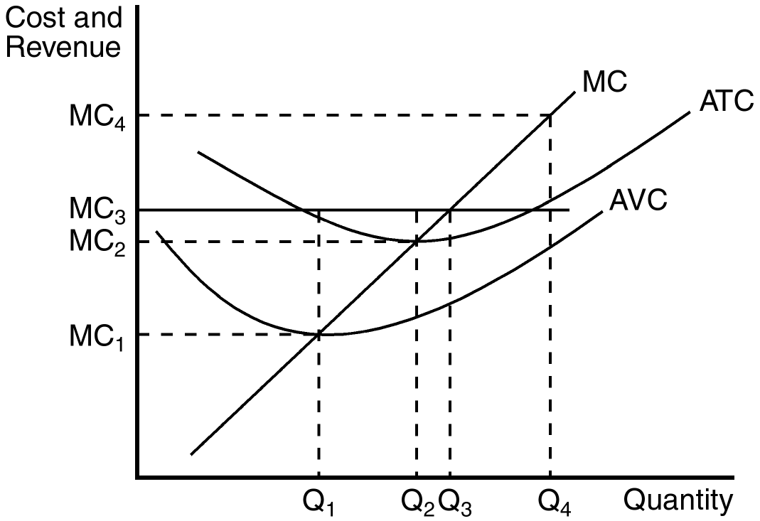

Note: On the above diagram, change the vertical-axis labels from MC1 to P1, MC2 to P2, etc.
52. When price is equal to P3, the profit-maximizing firm will produce what level of output?
a. Q1
b. Q2
c. Q3
d. Q4
ANSWER: c. Q3
TYPE: M DIFFICULTY: 2 SECTION: 14.2
53. When market price is at P2, a firm producing output level Q1 would experience
a. profits equal to (P2 – P1) × Q1.
b. losses equal to (P2 – P1) × Q1.
c. losses because P2 < ATC at output level Q1.
d. zero profits.
ANSWER: c. losses because P2 < ATC at output level Q1.
TYPE: M DIFFICULTY: 2 SECTION: 14.2
54. When market price is at P4, a profit-maximizing firm will produce what level of output?
a. Q1
b. Q2
c. Q3
d. Q4
ANSWER: d. Q4
TYPE: M DIFFICULTY: 2 SECTION: 14.2
55. When the price is P2 and the firm maximizes its profit or minimizes its loss, the firm
a. experiences a positive profit.
b. experiences a zero profit.
c. experiences a loss, but continues to operate.
d. shuts down.
ANSWER: b. experiences a zero profit.
TYPE: M DIFFICULTY: 2 SECTION: 14.2
56. When calculating marginal cost, what must the firm know?
a. sunk cost
b. variable cost
c. fixed cost
d. All of the above are correct.
ANSWER: b. variable cost
TYPE: M DIFFICULTY: 2 SECTION: 14.2
57. The additional revenue a firm in a competitive market receives if it increases its production by one unit equals its
a. marginal revenue.
b. average revenue.
c. price per unit of output.
d. All of the above are correct.
ANSWER: d. All of the above are correct.
TYPE: M DIFFICULTY: 2 SECTION: 14.2

The graph below depicts the cost structure for a firm in a competitive market. Use the graph to answer questions 58 through 61.

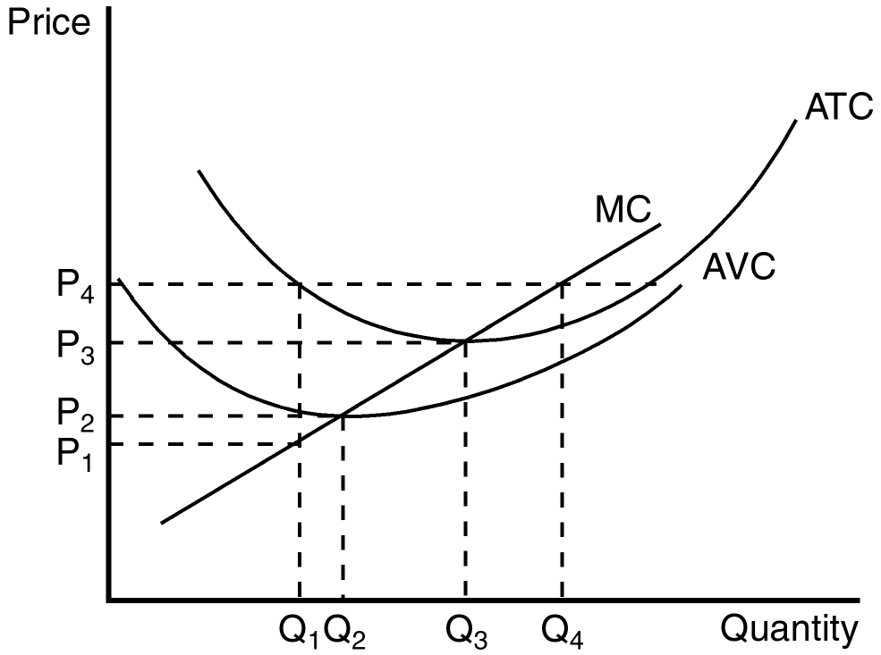

58. When price rises from P2 to P3, the firm finds that
a. marginal cost exceeds marginal revenue at a production level of Q2.
b. if it produces at output level Q3 it will earn a positive profit.
c. expanding output to Q4 would leave the firm with losses.
d. All of the above are correct.
ANSWER: c. expanding output to Q4 would leave the firm with losses.
TYPE: M DIFFICULTY: 2 SECTION: 14.2
59. When price falls from P3 to P1, the firm finds that
a. fixed cost is higher at a production level of Q1 than it is at Q3.
b. it should produce Q1 units of output.
c. it should produce Q3 units of output.
d. it is unwilling to produce any output.
ANSWER: d. it is unwilling to produce any output.
TYPE: M DIFFICULTY: 2 SECTION: 14.2
60. When price rises from P3 to P4, the firm finds that
a. fixed costs are lower at a production level of Q4.
b. it can earn a positive profit by increasing production to Q4.
c. profit is maximized at a production level of Q3.
d. average revenue exceeds marginal revenue at a production level of Q4.
ANSWER: b. it can earn a positive profit by increasing production to Q4.
TYPE: M DIFFICULTY: 2 SECTION: 14.2
61. Which of the following statements best reflects the situation faced by the firm when price falls from P4 to P2?
a. Average total cost is lower than at the previous level of output so it increases production.
b. The firm will earn profit equal to (P4 – P2) × Q2.
c. Marginal revenue is lower than marginal cost at the previous level of output, so it decreases production.
d. Marginal revenue is higher than marginal cost at the previous level of output, so it increases production.
ANSWER: c. Marginal revenue is lower than marginal cost at the previous level of output, so it decreases production.
TYPE: M DIFFICULTY: 2 SECTION: 14.2
62. A profit-maximizing firm in a competitive market will always make marginal adjustments to production as long as
a. average revenue is greater than average total cost.
b. average revenue is equal to marginal cost.
c. marginal cost is greater than average total cost.
d. price is above or below marginal cost.
ANSWER: d. price is above or below marginal cost.
TYPE: M DIFFICULTY: 2 SECTION: 14.2
63. When price is greater than marginal cost for a firm in a competitive market,
a. marginal cost must be falling.
b. the firm must be minimizing its losses.
c. there are opportunities to increase profit by increasing production.
d. the firm should decrease output to maximize profit.
ANSWER: c. there are opportunities to increase profit by increasing production.
TYPE: M DIFFICULTY: 2 SECTION: 14.2
64. The short-run supply curve for a firm in a perfectly competitive market is
a. likely to be horizontal.
b. likely to slope downward.
c. determined by forces external to the firm.
d. its marginal cost curve (above average variable cost).
ANSWER: d. its marginal cost curve (above average variable cost).
TYPE: M DIFFICULTY: 2 SECTION: 14.2
65. When a perfectly competitive firm makes a decision to shut down, it is most likely that
a. marginal cost is above average variable cost.
b. marginal cost is above average total cost.
c. price is below the minimum of average variable cost.
d. fixed costs exceed variable costs.
ANSWER: c. price is below the minimum of average variable cost.
TYPE: M DIFFICULTY: 2 SECTION: 14.2
66. When a firm makes a short-run decision not to produce anything during a specified period of time because of current market conditions, the firm is said to
a. shut down.
b. exit.
c. withdraw.
d. leave the industry.
ANSWER: a. shut down.
TYPE: M DIFFICULTY: 1 SECTION: 14.2
67. Firms that shut down in the short run still have to pay their
a. variable costs.
b. fixed costs.
c. total cost.
d. All of the above are correct.
ANSWER: b. fixed costs.
TYPE: M DIFFICULTY: 1 SECTION: 14.2
68. When total revenue is less than variable costs, a firm in a competitive market will
a. continue to operate as long as average revenue exceeds marginal cost.
b. continue to operate as long as average revenue exceeds average fixed cost.
c. shut down.
d. always exit the industry.
ANSWER: c. shut down.
TYPE: M DIFFICULTY: 2 SECTION: 14.2
69. When price is below average variable cost, a firm in a competitive market will
a. shut down and incur fixed costs.
b. shut down and incur both variable and fixed costs.
c. continue to operate as long as average revenue exceeds marginal cost.
d. continue to operate as long as average revenue exceeds average fixed cost.
ANSWER: a. shut down and incur fixed costs.
TYPE: M DIFFICULTY: 2 SECTION: 14.2
70. In 1999, sheepherders in the western United States slaughtered 10,000 sheep and buried them in large open pits rather than truck them to the market to be sold. This behavior is most likely explained by
a. sheepherders making a shut-down decision to save the variable cost of transporting sheep to a slaughter house.
b. sheepherders making an exit decision to recover the fixed cost of raising the sheep.
c. the rising marginal cost of producing sheep.
d. irrational behavior of sheepherders.
ANSWER: a. sheepherders making a shut-down decision to save the variable cost of transporting sheep to a slaughter house.
TYPE: M DIFFICULTY: 2 SECTION: 14.2

The figure below depicts the cost structure of a profit-maximizing firm in a competitive market. Use the figure to answer questions 71 and 72.

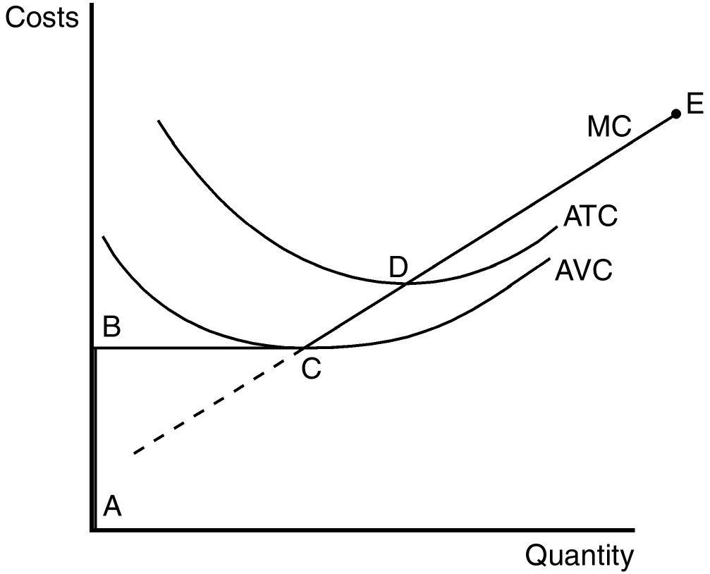

71. Which line segment best reflects the short-run supply curve for this firm?
a. BCD
b. CD
c. DE
d. None of the above are correct.
ANSWER: d. None of the above are correct.
TYPE: M DIFFICULTY: 2 SECTION: 14.2
72. If the firm is in a short-run position where P < AVC, it is most likely to be on what segment of its supply curve?
a. BC
b. CD
c. DE
d. None of the above are correct.
ANSWER: d. None of the above are correct.
TYPE: M DIFFICULTY: 2 SECTION: 14.2

The figure below depicts the cost structure of a profit-maximizing firm in a competitive market. Use the figure to answer questions 73 and 74.

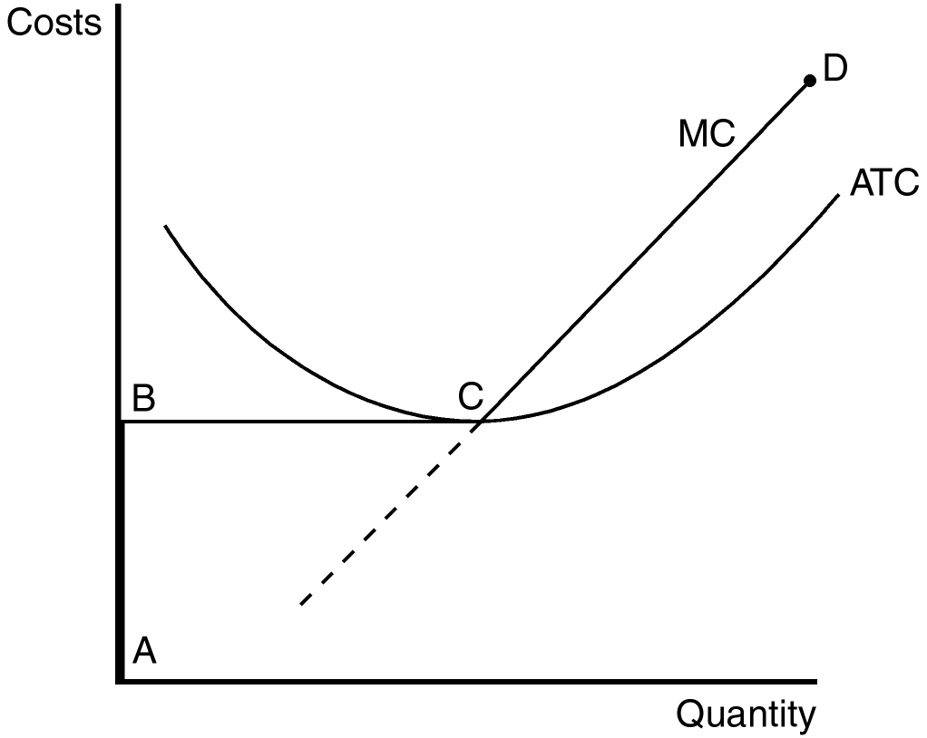

73. Which line segment best reflects the long-run supply curve for this firm?
a. AB
b. BC
c. CD
d. None of the above, the long-run supply curve requires knowledge of the average variable cost structure.
ANSWER: c. CD
TYPE: M DIFFICULTY: 2 SECTION: 14.2
74. This firm will exit the market for any price on the line segment
a. AB.
b. BC.
c. CD.
d. None of the above are correct.
ANSWER: a. AB.
TYPE: M DIFFICULTY: 2 SECTION: 14.2
75. When economists refer to a production cost that has already been committed and cannot be recovered, they use the term
a. implicit cost.
b. explicit cost.
c. variable cost.
d. sunk cost.
ANSWER: d. sunk cost.
TYPE: M DIFFICULTY: 1 SECTION: 14.2
76. A profit-maximizing firm in a competitive market produces small rubber balls. When the market price for small rubber balls falls below the minimum of its average total cost, but still lies above the minimum of average variable cost, the firm
a. will experience losses but it will continue to produce rubber balls.
b. will shut down.
c. will be earning both economic and accounting profits.
d. should raise the price of its product.
ANSWER: a. will experience losses but it will continue to produce rubber balls.
TYPE: M DIFFICULTY: 2 SECTION: 14.2
77. Which of the following statements best reflects the production decision of a profit-maximizing firm in a competitive market when price falls below the minimum of average variable cost?
a. The firm will continue to produce to attempt to pay fixed costs.
b. The firm will immediately stop production to minimize its losses.
c. The firm will stop production as soon as it is able to pay its sunk costs.
d. The firm will continue to produce in the short run but will likely exit the market in the long run.
ANSWER: b. The firm will immediately stop production to minimize its losses.
TYPE: M DIFFICULTY: 2 SECTION: 14.2
78. When fixed costs are ignored because they are irrelevant to a business’s production decision, they are called
a. explicit costs.
b. implicit costs.
c. sunk costs.
d. opportunity costs.
ANSWER: c. sunk costs.
TYPE: M DIFFICULTY: 1 SECTION: 14.2
79. The Wheeler Wheat Farm has a long-term lease on 5,000 acres of land in South Dakota. The annual lease payment is $250,000. Prior to planting in the spring of 2001, the Wheeler Farm economist predicted that the Farm would have $135,000 dollars left after paying all of its costs except the annual lease payment. In this case, the Wheeler Wheat Farm should
a. continue to operate because total revenue exceeds total cost.
b. continue to operate even though it predicts an accounting loss of $115,000.
c. shut down and experience an accounting loss of $135,000.
d. exit the market and experience an accounting loss of $250,000.
ANSWER: b. continue to operate even though it predicts an accounting loss of $115,000.
TYPE: M DIFFICULTY: 2 SECTION: 14.2
80. Shrimp Galore, a shrimp harvesting business in the Pacific Northwest, has a 30-year loan on its shrimp harvesting boat. The annual loan payment is $25,000 and the boat has a market (salvage) value that exceeds its outstanding loan balance. Prior to the 2001 shrimp harvesting season, Shrimp Galore’s accountant predicted that at expected market prices for shrimp, Shrimp Galore would have a net loss of $75,000 dollars after paying all 2001 expenses (including the annual loan payment). In this case, Shrimp Galore should
a. produce nothing and experience a loss of $25,000.
b. produce nothing and experience a loss of $75,000.
c. continue to operate because expected profits will rise in the future.
d. continue to operate even though it predicts a loss of $75,000.
ANSWER: a. produce nothing and experience a loss of $25,000.
TYPE: M DIFFICULTY: 2 SECTION: 14.2
81. A profit-maximizing firm will shut down in the short run when
a. price < average variable cost.
b. price < average total cost.
c. average revenue > marginal cost.
d. average revenue > average fixed cost.
ANSWER: a. price < average variable cost.
TYPE: M DIFFICULTY: 2 SECTION: 14.2
82. When a profit-maximizing firm in a competitive market is unable to generate enough revenue to pay all of its fixed costs it should, in the short run,
a. shut down and incur a loss equal to its fixed costs.
b. shut down until it is able to produce where average revenue exceeds average fixed cost.
c. continue to produce as long as marginal cost is less than average revenue.
d. continue to produce as long as total revenue is sufficient to pay variable costs.
ANSWER: d. continue to produce as long as total revenue is sufficient to pay variable costs.
TYPE: M DIFFICULTY: 2 SECTION: 14.2
83. In the long run all of a firm’s costs are variable. In this case the exit criterion for a profit-maximizing firm is
a. price < average total cost.
b. price > average total cost.
c. average revenue > average fixed cost.
d. average revenue > marginal cost.
ANSWER: a. price < average total cost.
TYPE: M DIFFICULTY: 2 SECTION: 14.2
84. When profit-maximizing firms in competitive markets are earning profits,
a. market demand must exceed market supply at the market equilibrium price.
b. market supply must exceed market demand at the market equilibrium price.
c. new firms will enter the market.
d. the most inefficient firms will be encouraged to leave the market.
ANSWER: c. new firms will enter the market.
TYPE: M DIFFICULTY: 2 SECTION: 14.2
85. Profit-maximizing firms enter a competitive market when, for existing firms in that market,
a. total revenue exceeds fixed costs.
b. total revenue exceeds total variable costs.
c. average total cost exceeds average revenue.
d. price exceeds average total cost.
ANSWER: d. price exceeds average total cost.
TYPE: M DIFFICULTY: 2 SECTION: 14.2

The figure below depicts the cost structure of a firm in a competitive market. Use the figure to answer questions 86 through 88.

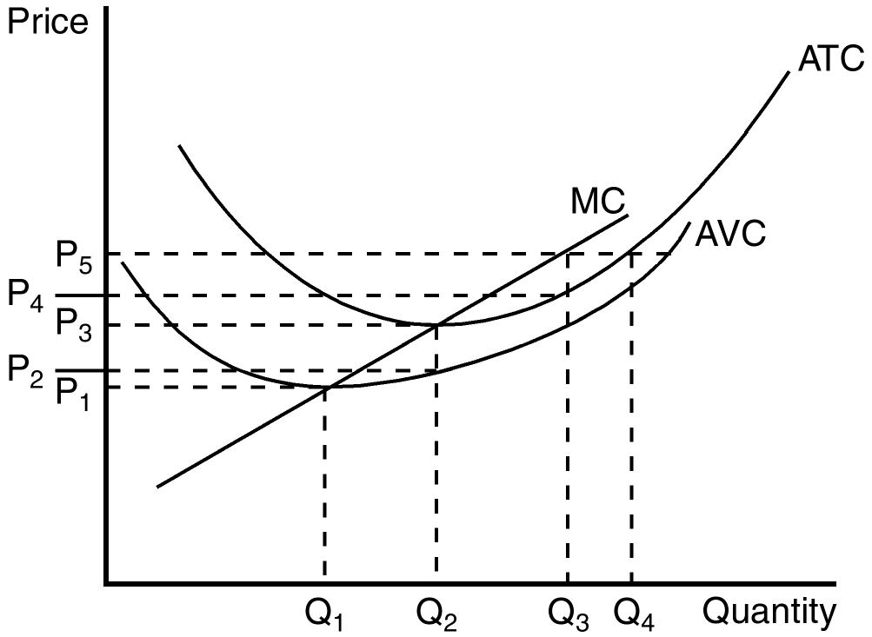

86. When market price is P5, a profit-maximizing firm’s profits can be represented by the area
a. P5 × Q3.
b. (P5 – P3) × Q2.
c. (P5 – P4) × Q3.
d. When market price is P5 there are no profits.
ANSWER: c. (P5 – P4) × Q3.
TYPE: M DIFFICULTY: 2 SECTION: 14.2
87. Firms would be encouraged to enter this market for all prices that exceed
a. P1.
b. P2.
c. P3.
d. None of the above are correct.
ANSWER: c. P3.
TYPE: M DIFFICULTY: 2 SECTION: 14.2
88. When market price is P2, a profit-maximizing firm’s losses can be represented by the area
a. (P3 – P2) × Q2.
b. (P2 – P1) × Q2.
c. At a market price of P2, the firm does not have losses.
d. At a market price of P2 the firm has losses, but the reference points in the figure don’t identify the losses.
ANSWER: d. At a market price of P2 the firm has losses, but the reference points in the figure don’t identify the losses.
TYPE: M DIFFICULTY: 2 SECTION: 14.2

The figure below depicts the cost structure of a firm in a competitive market. Use the figure to answer questions 89 through 91.

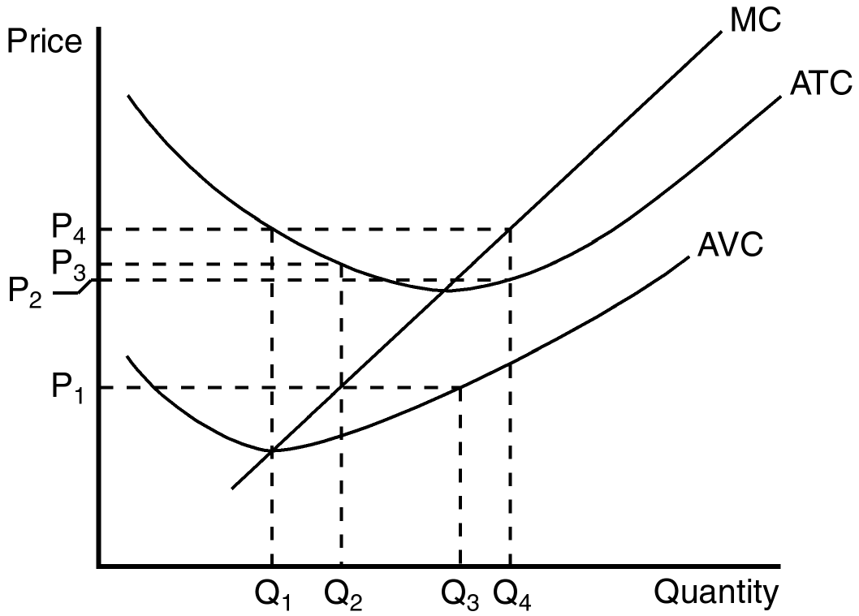

89. When market price is P1, a profit-maximizing firm’s total revenue can be represented by the area
a. P1 × Q2.
b. P2 × Q2.
c. P3 × Q2.
d. P1 × Q3.
ANSWER: a. P1 × Q2.
TYPE: M DIFFICULTY: 2 SECTION: 14.2
90. When market price is P4, a profit-maximizing firm’s total cost can be represented by the area
a. P4 × Q1
b. P4 × Q4
c. P2 × Q4
d. Total costs cannot be determined from the information in the figure.
ANSWER: c. P2 × Q4
TYPE: M DIFFICULTY: 2 SECTION: 14.2
91. When market price is P1, a profit-maximizing firm’s total profit or loss can be represented by which area?
a. P1 × Q3; profit
b. (P3 – P1) × Q2 ; loss
c. (_P2 – P1) × Q1; loss
d. We can’t tell because we don’t know fixed costs.
ANSWER: b. (P3 – P1) × Q2 ; loss
TYPE: M DIFFICULTY: 2 SECTION: 14.2
92. When a profit-maximizing firm is earning profits, those profits can be identified by
a. P × Q.
b. (MC – AVC) × Q.
c. (P – ATC) × Q.
d. (P – AVC) × Q.
ANSWER: c. (P – ATC) × Q.
TYPE: M DIFFICULTY: 2 SECTION: 14.2
93. When a profit-maximizing firm finds itself minimizing losses because it is unable to earn a positive profit, this task is accomplished by producing the quantity at which price is equal to
a. sunk cost.
b. average fixed cost.
c. average variable cost.
d. marginal cost.
ANSWER: d. marginal cost.
TYPE: M DIFFICULTY: 2 SECTION: 14.2
94. When a profit-maximizing firm’s fixed costs are considered sunk in the short run, then the firm
a. can set price above marginal cost.
b. must set price below average total cost.
c. will never show losses.
d. can safely ignore fixed costs when deciding how much output to produce.
ANSWER: d. can safely ignore fixed costs when deciding how much output to produce.
TYPE: M DIFFICULTY: 2 SECTION: 14.2
95. A firm’s short-run supply curve is part of which of the following curves?
a. marginal revenue
b. average variable cost
c. average total cost
d. marginal cost
ANSWER: d. marginal cost
TYPE: M DIFFICULTY: 2 SECTION: 14.2
96. The irrelevance of sunk costs is best described by which of the following business decisions?
a. New airlines enter the market and earn profits.
b. Airlines continue to sell tickets even though they are reporting large losses.
c. Airlines exit the market when they report losses.
d. All of the above are correct.
ANSWER: b. Airlines continue to sell tickets even though they are reporting large losses.
TYPE: M DIFFICULTY: 2 SECTION: 14.2
97. If a profit-maximizing firm in a competitive market discovers that at its current level of production price is greater than marginal cost it should
a. shut down.
b. reduce its output, but continue operating.
c. keep output the same.
d. increase its output.
ANSWER: d. increase its output.
TYPE: M DIFFICULTY: 2 SECTION: 14.2
98. For any given price, a firm in a competitive market will maximize profit by selecting the level of output at which price intersects the
a. average total cost curve.
b. average variable cost curve.
c. marginal cost curve.
d. marginal revenue curve.
ANSWER: c. marginal cost curve.
TYPE: M DIFFICULTY: 2 SECTION: 14.2
99. By comparing marginal revenue and marginal cost, a firm in a competitive market is able to adjust production to the level that achieves its objective, which we assume to be
a. maximization of total revenue.
b. maximization of profit.
c. minimization of variable cost.
d. minimization of average total cost.
ANSWER: b. maximization of profit.
TYPE: M DIFFICULTY: 2 SECTION: 14.2
100. Assume that Sarah places a $70 value on seeing her college football team play in the Rose Bowl. She purchases a ticket to the game for $50 but when she arrives at the game she discovers that her ticket is missing. A ticket scalper outside the stadium is selling tickets for $65 dollars. If Sarah purchases a ticket from one of the scalpers for $65, she is best demonstrating the principle that
a. sunk costs are irrelevant to many personal decisions.
b. the price of tickets cannot be explained by economic principles.
c. the assumption of rational behavior does not easily apply to the purchase of college football game tickets.
d. rational consumers do not always respond to incentives.
ANSWER: a. sunk costs are irrelevant to many personal decisions.
TYPE: M DIFFICULTY: 2 SECTION: 14.2
101. When a restaurant stays open for lunch service even though few customers patronize the restaurant for lunch, which of the following principles is (are) best demonstrated?
(i) Fixed costs are sunk in the short run.
(ii) In the short run, only fixed costs are important to the decision to stay open for lunch.
(iii) If revenue exceeds variable cost, the restaurant owner is making a profitable strategic decision to remain open for lunch.
a. (i) and (ii) only
b. (ii) and (iii) only
c. (i) and (iii) only
d. All are demonstrated.
ANSWER: c. (i) and (iii) only
TYPE: M DIFFICULTY: 2 SECTION: 14.2
102. In the long run, a profit-maximizing firm will choose to exit a market when
a. average fixed cost is falling.
b. variable costs exceed sunk costs.
c. marginal cost exceeds marginal revenue at the current level of production.
d. total revenue is less than total cost.
ANSWER: d. total revenue is less than total cost.
TYPE: M DIFFICULTY: 2 SECTION: 14.2
103. One of the most important determinants of the success of free-market capitalism is
a. enlightened governments selecting firms that should not be allowed to exit a market.
b. free entry and exit in markets.
c. government regulation of market participants.
d. having a few large firms rather than thousands of small ones.
ANSWER: b. free entry and exit in markets.
TYPE: M DIFFICULTY: 2 SECTION: 14.2
104. A profit-maximizing firm in a competitive market is currently producing 100 units of output. It has average revenue of $10, and its average total cost is $8. It follows that the firm’s
a. average total cost curve intersects the marginal cost curve at an output level of less than100 units.
b. average variable cost curve intersects the marginal cost curve at an output level of less than 100 units.
c. profit is $200.
d. All of the above are correct.
ANSWER: d. All of the above are correct.
TYPE: M DIFFICULTY: 3 SECTION: 14.2
105. A profit-maximizing firm in a competitive market is able to sell its product for $9. At its current level of output the firm’s average total cost is $11. Its marginal cost curve crosses the marginal revenue curve at an output level of 10 units. Then the firm experiences a
a. profit of more than $20.
b. profit of exactly $20.
c. loss of more than $20.
d. loss of exactly $20.
ANSWER: d. loss of exactly $20.
TYPE: M DIFFICULTY: 2 SECTION: 14.2
106. If a competitive firm is currently producing a level of output at which marginal revenue exceeds marginal cost, then
a. a one-unit increase in output will increase the firm’s profit.
b. a one-unit decrease in output will increase the firm’s profit.
c. total revenue exceeds total cost.
d. total cost exceeds total revenue.
ANSWER: a. a one-unit increase in output will increase the firm’s profit.
TYPE: M DIFFICULTY: 2 SECTION: 14.2
107. If a competitive firm is currently producing a level of output at which marginal cost exceeds marginal revenue, then
a. average revenue exceeds marginal cost.
b. the firm is earning a positive profit.
c. a one-unit decrease in output would increase the firm’s profit.
d. All of the above are correct.
ANSWER: c. a one-unit decrease in output would increase the firm’s profit.
TYPE: M DIFFICULTY: 3 SECTION: 14.2
108. If a competitive firm is currently producing a level of output at which profit is not maximized, then it must be true that
a. marginal revenue exceeds marginal cost.
b. marginal cost exceeds marginal revenue.
c. total cost exceeds total revenue.
d. None of the above are correct.
ANSWER: d. None of the above are correct.
TYPE: M DIFFICULTY: 2 SECTION: 14.2
109. At the profit-maximizing level of output,
a. marginal revenue = average total cost.
b. marginal revenue = average variable cost.
c. marginal revenue = marginal cost.
d. average revenue = average total cost.
ANSWER: c. marginal revenue = marginal cost.
TYPE: M DIFFICULTY: 2 SECTION: 14.2
110. The intersection of a firm’s marginal revenue and marginal cost curves determines the level of output at which
a. total revenue is equal to variable cost.
b. total revenue is equal to fixed cost.
c. total revenue is equal to total cost.
d. profit is maximized.
ANSWER: d. profit is maximized.
TYPE: M DIFFICULTY: 2 SECTION: 14.2
111. For a certain firm, the 100th unit of output that the firm produces has a marginal revenue of $10 and a marginal cost of $7. It follows that
a. the production of the 100th unit of output increases the firm’s profit by $3.
b. the production of the 100th unit of output increases the firm’s average total cost by $7.
c. the firm’s profit-maximizing level of output is less than 100 units.
d. All of the above are correct.
ANSWER: a. the production of the 100th unit of output increases the firm’s profit by $3.
TYPE: M DIFFICULTY: 2 SECTION: 14.2
112. A certain competitive firm sells its output for $20 per unit. The 50th unit of output that the firm produces has a marginal cost of $22. It follows that the production of the 50th unit of output
a. increases the firm’s total revenue by $20.
b. increases the firm’s total cost by $22.
c. decreases the firm’s profit by $2.
d. All of the above are correct.
ANSWER: d. All of the above are correct.
TYPE: M DIFFICULTY: 2 SECTION: 14.2
Refer to the following information to answer Questions 113 through 116.

Assume a certain firm is producing 1,000 units of output (so Q = 1,000). At Q = 1,000, the firm’s marginal cost equals $15 and its average total cost equals $11. The firm sells its output for $12 per unit.
113. At Q = 1,000, the firm’s profit amounts to
a. $–200.
b. $1,000.
c. $3,000.
d. $4,000.
ANSWER: b. $1,000.
TYPE: M DIFFICULTY: 2 SECTION: 14.2
114. At Q = 999, the firm’s total cost amounts to
a. $10,985.
b. $10,990.
c. $10,995.
d. $10,999.
ANSWER: a. $10,985.
TYPE: M DIFFICULTY: 3 SECTION: 14.2
115. At Q = 999, the firm’s profit amounts to
a. $993.
b. $997.
c. $1,003.
d. $1,007.
ANSWER: c. $1,003.
TYPE: M DIFFICULTY: 3 SECTION: 14.2
116. To maximize its profit, the firm should
a. increase its output.
b. continue to produce 1,000 units.
c. decrease its output, but continue to produce.
d. shut down.
ANSWER: c. decrease its output, but continue to produce.
TYPE: M DIFFICULTY: 2 SECTION: 14.2
117. Which of these curves is the competitive firm’s supply curve?
a. the average variable cost curve above marginal cost
b. the average total cost curve above marginal cost
c. the marginal cost curve above average variable cost
d. the average fixed cost curve
ANSWER: c. the marginal cost curve above average variable cost
TYPE: M DIFFICULTY: 2 SECTION: 14.2
118. A competitive firm’s marginal cost curve is regarded as its supply curve because
a. the position of the marginal cost curve determines the price for which the firm should sell its product.
b. among the various cost curves, the marginal cost curve is the only one that slopes upward.
c. the marginal cost curve determines the quantity of output the firm is willing to supply at any price.
d. the firm is aware that marginal revenue must exceed marginal cost in order for profit to be maximized.
ANSWER: c. the marginal cost curve determines the quantity of output the firm is willing to supply at any price.
TYPE: M DIFFICULTY: 2 SECTION: 14.2
119. To begin, a competitive firm is selling its output for $20 per unit and it is maximizing its profit, which is positive. Now, the price rises to $25 and the firm makes whatever adjustments are necessary to maximize its profit at the now-higher price. Once the firm has adjusted, which of the following statements is correct?
a. The firm’s quantity of output is higher than it was previously.
b. The firm’s average total cost is higher than it was previously.
c. The firm’s average revenue is higher than it was previously.
d. All of the above are correct.
ANSWER: d. All of the above are correct.
TYPE: M DIFFICULTY: 2 SECTION: 14.2
120. To begin, a competitive firm is selling its output for $10 per unit and it is maximizing its profit. Now, the price rises to $14 and the firm makes whatever adjustments are necessary to maximize its profit at the now-higher price. Once the firm has adjusted, which of the following statements is correct?
a. The firm’s marginal revenue is lower than it was previously.
b. The firm’s marginal cost is lower than it was previously.
c. The firm’s quantity of output is higher than it was previously.
d. All of the above are correct.
ANSWER: c. The firm’s quantity of output is higher than it was previously.
TYPE: M DIFFICULTY: 2 SECTION: 14.2
121. Which of the following statements is correct regarding a firm’s decisionmaking?
a. The decision to shut down and the decision to exit are both short-run decisions.
b. The decision to shut down and the decision to exit are both long-run decisions.
c. The decision to shut down is a short-run decision, whereas the decision to exit is a long-run decision.
d. The decision to exit is a short-run decision, whereas the decision to shut down is a long-run decision.
ANSWER: c. The decision to shut down is a short-run decision, whereas the decision to exit is a long-run decision.
TYPE: M DIFFICULTY: 2 SECTION: 14.2
122. A firm that shuts down temporarily
a. still has to pay its variable costs, but not its fixed costs.
b. still has to pay its fixed costs, but not its variable costs.
c. still has to pay both its variable costs and its fixed costs.
d. has to pay neither its variable costs nor its fixed costs.
ANSWER: b. still has to pay its fixed costs, but not its variable costs.
TYPE: M DIFFICULTY: 2 SECTION: 14.2
123. A firm that exits its market
a. still has to pay its variable costs, but not its fixed costs.
b. still has to pay its fixed costs, but not its variable costs.
c. still has to pay both its variable costs and its fixed costs.
d. has to pay neither its variable costs nor its fixed costs.
ANSWER: d. has to pay neither its variable costs nor its fixed costs.
TYPE: M DIFFICULTY: 2 SECTION: 14.2
124. A firm will shut down in the short run if the total revenue that it would get from producing and selling its output is less than its
a. opportunity costs.
b. fixed costs.
c. variable costs.
d. total costs.
ANSWER: c. variable costs.
TYPE: M DIFFICULTY: 2 SECTION: 14.2
125. A firm will shut down in the short run if, for all positive levels of output,
a. its loss exceeds its fixed costs.
b. its total revenue is less than its variable costs.
c. the price of its product is less than its average variable cost.
d. All of the above are correct.
ANSWER: d. All of the above are correct.
TYPE: M DIFFICULTY: 2 SECTION: 14.2
126. A firm’s marginal cost has a minimum value of $2; its average variable cost has a minimum value of $4; and its average total cost has a minimum value of $5. Then the firm will shut down if the price of its product falls below
a. $2.
b. $4.
c. $5.
d. There is not enough information given to answer the question.
ANSWER: b. $4.
TYPE: M DIFFICULTY: 2 SECTION: 14.2
127. The complete description of a competitive firm’s supply curve is as follows: The competitive firm’s short-run supply curve is that portion of the
a. average variable cost curve that lies above marginal cost.
b. average total cost curve that lies above marginal cost.
c. marginal cost curve that lies above average variable cost.
d. marginal cost curve that lies above average total cost.
ANSWER: c. marginal cost curve that lies above average variable cost.
TYPE: M DIFFICULTY: 2 SECTION: 14.2
128. The complete description of a competitive firm’s short-run supply curve is as follows: The competitive firm’s short-run supply curve is that portion of the marginal cost curve that lies above average
a. fixed cost.
b. variable cost.
c. total cost.
d. revenue.
ANSWER: b. variable cost.
TYPE: M DIFFICULTY: 2 SECTION: 14.2
129. Which of these types of costs can be ignored when an individual or a firm is making decisions?
a. sunk costs
b. marginal costs
c. variable costs
d. information costs
ANSWER: a. sunk costs
TYPE: M DIFFICULTY: 1 SECTION: 14.2
130. Suppose you bought a ticket to a football game for $30, and that you place a $35 value on seeing the game. If you lose the ticket, then what is the maximum price you should pay for another ticket?
a. $30
b. $35
c. $60
d. $65
ANSWER: b. $35
TYPE: M DIFFICULTY: 2 SECTION: 14.2
131. A firm will exit a market if, for all positive levels of output,
a. its total revenue is less than its total cost.
b. its profit is negative.
c. the price of its product is less than its average total cost.
d. All of the above are correct.
ANSWER: d. All of the above are correct.
TYPE: M DIFFICULTY: 2 SECTION: 14.2
132. The competitive firm’s long-run supply curve is that portion of the marginal cost curve that lies above average
a. fixed cost.
b. variable cost.
c. total cost.
d. revenue.
ANSWER: c. total cost.
TYPE: M DIFFICULTY: 2 SECTION: 14.2
133. Which of the following expressions is correct?
a. Profit = (Price of output – Average total cost) × Quantity of output.
b. Profit = (Price of output × Quantity of output) – Average total cost.
c. Profit = Total revenue – (Average total cost/Quantity of output).
d. Profit = Total revenue – (Average variable cost × Quantity of output).
ANSWER: a. Profit = (Price of output – Average total cost) × Quantity of output.
TYPE: M DIFFICULTY: 2 SECTION: 14.2
134. Assume a firm is producing 800 units of output, and it sells each unit for $6. Its average total cost is $4. Its profit is
a. $–1,600.
b. $1,600.
c. $3,200.
d. $8,000.
ANSWER: b. $1,600.
TYPE: M DIFFICULTY: 2 SECTION: 14.2
135. Susan quit her job as a teacher, which paid her $36,000 per year in order to start her own catering business. She spent $12,000 of her savings, which had been earning 10 percent interest per year, on equipment for her business. She also borrowed $12,000 from her bank at 10 percent interest, which she also spent on equipment. For the past several months she has spent $1,000 per month on ingredients and other variable costs. Also for the past several months she has taken in $3,500 in monthly revenue.
a. In the short run, Susan should shut down her business and in the long run she should exit the industry.
b. In the short run, Susan should continue to operate her business, but in the long run she should exit the industry.
c. In the short run, Susan should continue to operate her business, but in the long run she will probably face competition from newly entering firms.
d. In the short run, Susan should continue to operate her business, and she is also in long-run equilibrium.
ANSWER: b. In the short run, Susan should continue to operate her business, but in the long run she should exit the industry.
TYPE: M DIFFICULTY: 3 SECTION: 14.2
136. A firm in a competitive market has the following cost structure:

Output Total Cost
0 $5
1 $10
2 $12
3 $15
4 $24
5 $40

This firm will shut down
a. if price falls below $3.33 and exit if it falls below $5.
b. if price falls below $5 and exit if it falls below $3.33.
c. if price falls below $7 and exit if it falls below $10.
d. and exit if price falls below $5.
ANSWER: a. if price falls below $3.33 and exit if it falls below $5.
TYPE: M DIFFICULTY: 3 SECTION: 14.2
137. A firm in a competitive market has the following cost structure:

Output Total Cost
0 $5
1 $10
2 $12
3 $15
4 $24
5 $40

If the market price is $4, this firm will
a. produce two units in the short run and exit in the long run.
b. produce three units in the short run and exit in the long run.
c. produce four units in the short run and exit in the long run.
d. shut down in the short run and exit in the long run.
ANSWER: b. produce three units in the short run and exit in the long run.
TYPE: M DIFFICULTY: 3 SECTION: 14.2
138. A competitive market is in long-run equilibrium. If demand decreases, we can be certain that price will
a. fall in the short run. All firms will shut down and some of them will exit the industry. Price will then rise.
b. fall in the short run. No firms will shut down, but some of them will exit the industry. Price will then rise.
c. fall in the short run. All, some, or no firms will shut down, and some of them will exit the industry. Price will then rise.
d. not fall in the short run because firms will exit to maintain the price.
ANSWER: c. fall in the short run. All, some or no firms will shut down, and some of them will exit the industry. Price will then rise.
TYPE: M DIFFICULTY: 3 SECTION: 14.2
139. In a market with 1,000 identical firms, the short-run market supply is the
a. marginal cost curve (above average variable cost) for a typical firm in the market.
b. quantity supplied by the typical firm in the market.
c. sum of the prices charged by each of the 1,000 individual firms.
d. sum of the quantities supplied by each of the 1,000 individual firms.
ANSWER: d. sum of the quantities supplied by each of the 1,000 individual firms.
TYPE: M DIFFICULTY: 2 SECTION: 14.3

In the figure below, panel (a) depicts the linear marginal cost of a firm in a competitive market and panel (b) depicts the linear market supply curve for a market with a fixed number of identical firms. Use the figure to answer questions 140 through 142.

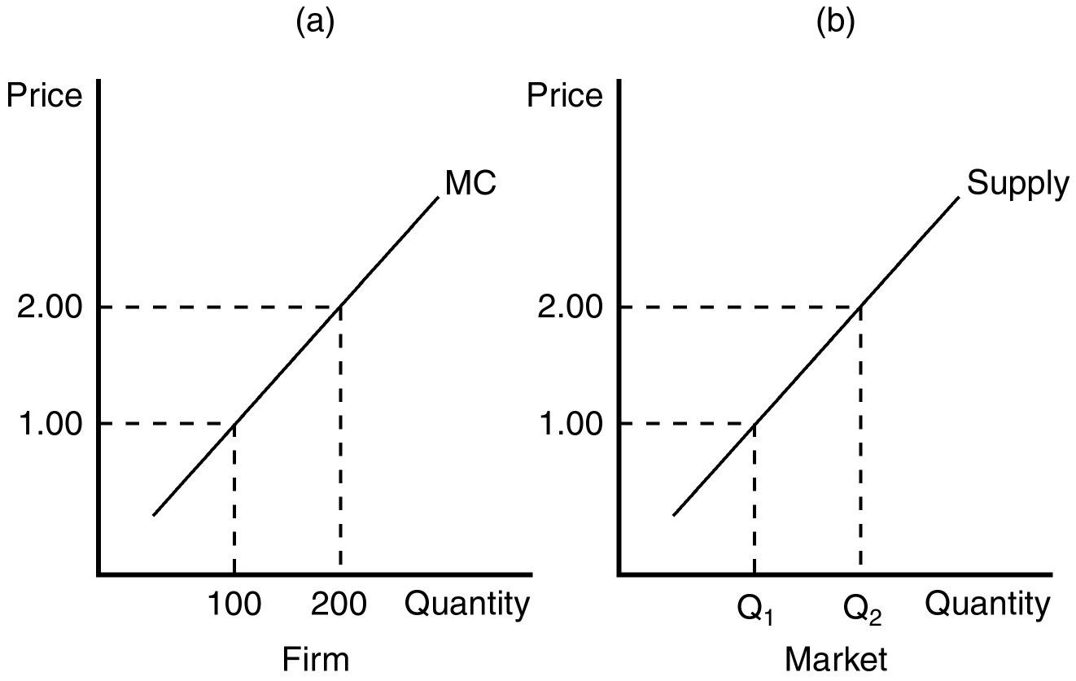

140. If there are 200 identical firms in this market, what level of output will be supplied to the market when price is $1.00?
a. 2,000
b. 5,000
c. 10,000
d. 20,000
ANSWER: d. 20,000
TYPE: M DIFFICULTY: 2 SECTION: 14.3
141. When 100 identical firms participate in this market, at what price will 15,000 units be supplied to this market?
a. $1.00
b. $1.50
c. $2.00
d. It cannot be determined from the information provided.
ANSWER: b. $1.50
TYPE: M DIFFICULTY: 2 SECTION: 14.3
142. If at a market price of $1.75, 52,500 units of output are supplied to this market, how many identical firms are participating in this market?
a. 75
b. 100
c. 250
d. 300
ANSWER: d. 300
TYPE: M DIFFICULTY: 3 SECTION: 14.3
143. When existing firms in a competitive market are profitable, an incentive exists for
a. new firms to seek government subsidies that would allow them to enter the market.
b. new firms to enter the market, even without government subsidies.
c. existing firms to raise prices.
d. existing firms to increase production.
ANSWER: b. new firms to enter the market, even without government subsidies.
TYPE: M DIFFICULTY: 2 SECTION: 14.3
144. When new firms have an incentive to enter a competitive market, their entry will
a. increase the price of the product.
b. drive down profits of existing firms in the market.
c. shift the market supply curve to the left.
d. All of the above are correct.
ANSWER: b. drive down profits of existing firms in the market.
TYPE: M DIFFICULTY: 2 SECTION: 14.3
145. When firms have an incentive to exit a competitive market, their exit will
a. lower market price.
b. necessarily raise the costs of firms that remain in the market.
c. raise profits for firms that remain in the market.
d. All of the above are correct.
ANSWER: c. raise profits for firms that remain in the market.
TYPE: M DIFFICULTY: 2 SECTION: 14.3
146. In a perfectly competitive market, the process of entry and exit will end when, for firms in the market,
a. price is equal to average variable cost.
b. marginal revenue is equal to average variable cost.
c. economic profits are zero.
d. All of the above are correct.
ANSWER: c. economic profits are zero.
TYPE: M DIFFICULTY: 2 SECTION: 14.3
Use the figures below to answer questions 147 and 148.

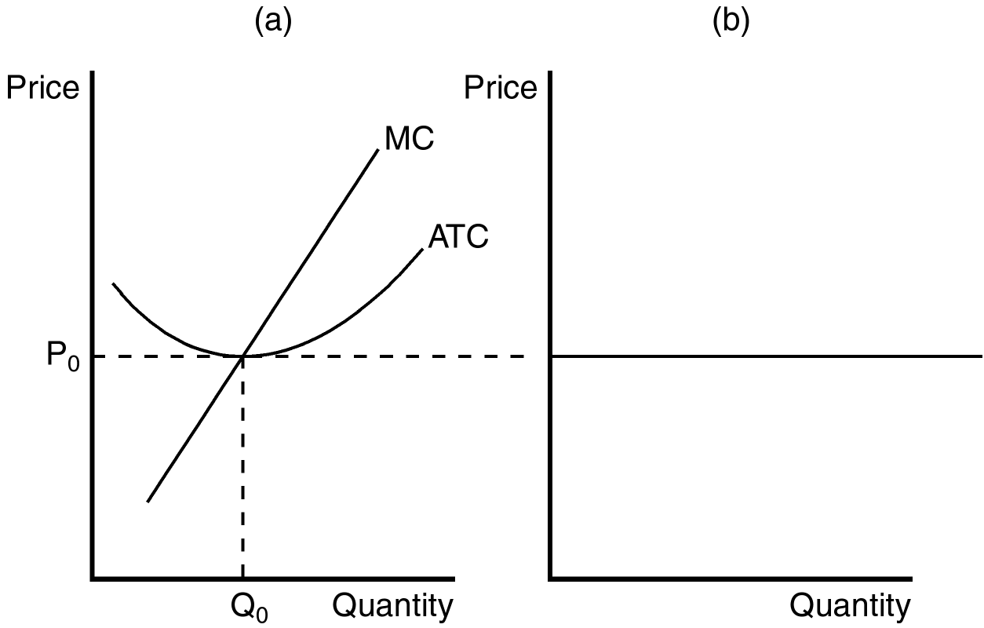

147. If the figure in panel (a) reflects the long-run equilibrium of a profit-maximizing firm in a competitive market, the figure in panel (b) is most likely to reflect long-run market
a. strategy.
b. production capacity.
c. demand.
d. supply.
ANSWER: d. supply.
TYPE: M DIFFICULTY: 2 SECTION: 14.3
148. If the figure in panel (a) reflects the long-run equilibrium of a profit-maximizing firm in a competitive market, the figure in panel (b) most likely reflects
a. perfectly inelastic long-run market supply.
b. the idea that free entry and exit of firms in the market lead to only one market price in the long run.
c. the product of the individual supply curves for all firms in the market.
d. the fact that zero profits cannot be sustained in the long run.
ANSWER: b. the idea that free entry and exit of firms in the market lead to only one market price in the long run.
TYPE: M DIFFICULTY: 2 SECTION: 14.3
149. In a market that allows free entry and exit, the process of entry and exit ends when, for the typical firm in the market,
a. profit is zero.
b. total revenue is equal to average total cost.
c. average revenue exceeds marginal cost.
d. All of the above are correct.
ANSWER: a. profit is zero.
TYPE: M DIFFICULTY: 2 SECTION: 14.3
150. When new firms enter a perfectly competitive market,
a. demand increases.
b. the short-run market supply curve shifts right.
c. the short-run market supply curve shifts left.
d. existing firms will increase prices in response to the entry of the new firms.
ANSWER: b. the short-run market supply curve shifts right.
TYPE: M DIFFICULTY: 2 SECTION: 14.3
151. When new firms enter a perfectly competitive market,
a. profits of existing firms will fall.
b. entering firms will earn zero profit as soon as they enter.
c. existing firms will see their costs rise.
d. consumers will likely observe increasing prices.
ANSWER: a. profits of existing firms will fall.
TYPE: M DIFFICULTY: 2 SECTION: 14.3
152. In a competitive market that is characterized by free entry and exit,
a. all firms will operate at efficient scale in the short run.
b. all firms will operate at efficient scale in the long run.
c. the price of the product will differ across firms.
d. the number of sellers in the market will steadily decrease over time.
ANSWER: b. all firms will operate at efficient scale in the long run.
TYPE: M DIFFICULTY: 2 SECTION: 14.3
153. If all existing firms and all potential firms have the same cost curves, there are no inputs in limited quantities, and the market is characterized by free entry and exit, then the long-run
a. market supply curve is equal to the sum of marginal cost.
b. supply curve for the market must slope downward.
c. market supply curve must slope upward.
d. supply curve for the market is horizontal and equal to the minimum of long-run average cost for each firm.
ANSWER: d. supply curve for the market is horizontal and equal to the minimum of long-run average cost for each firm.
TYPE: M DIFFICULTY: 2 SECTION: 14.3
154. When all firms and potential firms in a market have the same cost curves, the long-run equilibrium of a competitive market with free entry and exit will be characterized by firms
a. earning small levels of economic profit.
b. facing the prospect of future losses.
c. operating at efficient scale.
d. that band together to raise market prices.
ANSWER: c. operating at efficient scale.
TYPE: M DIFFICULTY: 2 SECTION: 14.3
Use the following information to answer questions 155 and 156.

In March of 2000 a study sponsored by the Food Consumer Safety Board found that consumption of irradiated grapefruit increased the health of laboratory rats. As a result of national press coverage of the report, the demand for irradiated grapefruit increased dramatically. Organic farmers were able to switch from organic production of grapefruit to irradiated production with no additional cost. Assume that the grapefruit market satisfies all of the attributes of perfect competition.
155. As a result of the increase in the demand for grapefruit, we would predict that in the short run the
a. production of grapefruit would be at efficient scale.
b. price of grapefruit would rise.
c. total cost for existing irradiated grapefruit producers must rise.
d. All of the above are correct.
ANSWER: b. price of grapefruit would rise.
TYPE: M DIFFICULTY: 2 SECTION: 14.3
156. If the increased production of irradiated grapefruit caused a rise in the marginal transportation costs of moving irradiated grapefruit to market, the
a. short-run market supply curve for irradiated grapefruit would be affected, but not the long-run market supply.
b. long-run market supply curve for irradiated grapefruit would be perfectly elastic.
c. long-run market supply of irradiated grapefruit would be downward sloping.
d. long-run market supply of irradiated grapefruit would be upward sloping.
ANSWER: d. long-run market supply of irradiated grapefruit would be upward sloping.
TYPE: M DIFFICULTY: 2 SECTION: 14.3
157. In long-run equilibrium of a competitive market, the number of firms in the market adjusts so that all of the market demand is satisfied at a price equal to
a. sunk cost.
b. the maximum value of marginal cost.
c. the minimum value of average total cost.
d. the minimum value of average variable cost.
ANSWER: c. the minimum value of average total cost.
TYPE: M DIFFICULTY: 2 SECTION: 14.3
158. The entry of new firms into a competitive market will
a. increase market supply and increase market prices.
b. increase market supply and decrease market prices.
c. decrease market supply and increase market prices.
d. decrease market supply and decrease market prices.
ANSWER: b. increase market supply and decrease market prices.
TYPE: M DIFFICULTY: 2 SECTION: 14.3
159. When calculating economic profit, total costs include
a. opportunity costs.
b. fixed costs.
c. variable costs.
d. All of the above are correct.
ANSWER: d. All of the above are correct.
TYPE: M DIFFICULTY: 1 SECTION: 14.3
160. The exit of existing firms from a competitive market will
a. increase market supply and increase market prices.
b. increase market supply and decrease market prices.
c. decrease market supply and increase market prices.
d. decrease market supply and decrease market prices.
ANSWER: c. decrease market supply and increase market prices.
TYPE: M DIFFICULTY: 2 SECTION: 14.3
161. The entry and exit decisions of firms in a competitive market are signaled by
a. high or low demand for a firm’s product.
b. high capital costs.
c. low capital costs.
d. profits and losses.
ANSWER: d. profits and losses.
TYPE: M DIFFICULTY: 2 SECTION: 14.3
162. When firms are neither entering nor exiting a perfectly competitive market,
a. total cost must equal total revenue.
b. economic profits must be zero.
c. average revenue must equal average total cost.
d. All of the above are correct.
ANSWER: d. All of the above are correct.
TYPE: M DIFFICULTY: 2 SECTION: 14.3
163. When entry and exit behavior of firms in an industry does not affect a firm’s cost structure,
a. the long-run market supply curve must be horizontal.
b. the long-run market supply curve must be upward-sloping.
c. the long-run market supply curve must be downward-sloping.
d. we can’t tell anything about the shape of the long-run market supply curve.
ANSWER: a. the long-run market supply curve must be horizontal.
TYPE: M DIFFICULTY: 2 SECTION: 14.3

Use the figures below to answer questions 164 through 168.

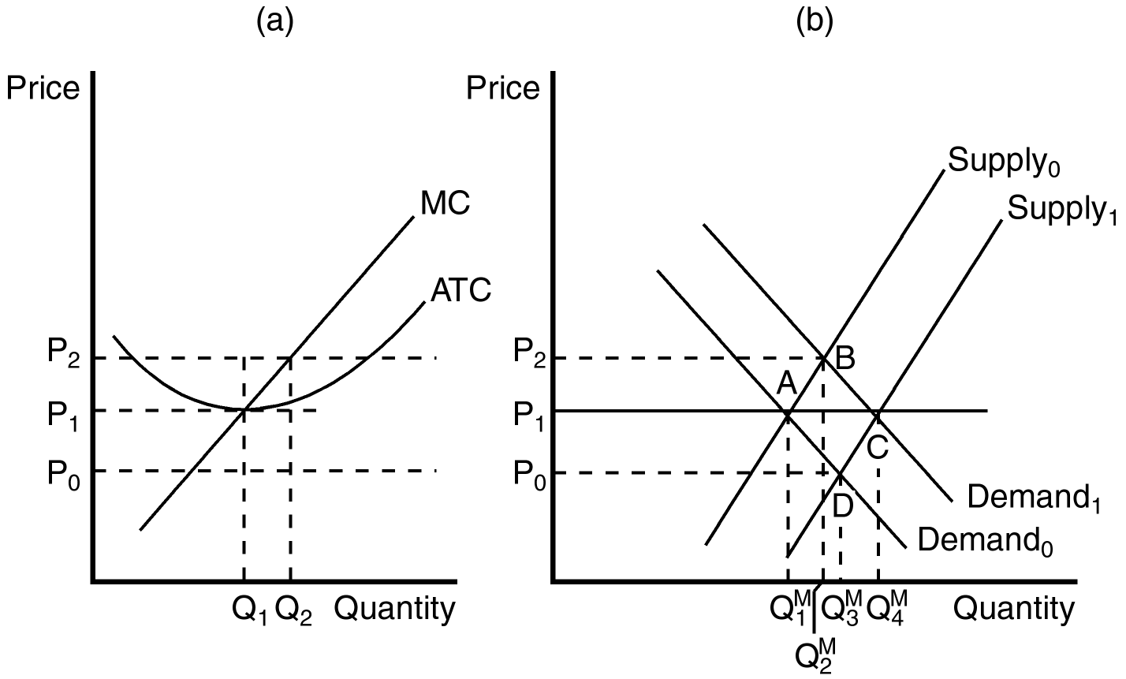

164. When the market is in long-run equilibrium at point A in panel (b), the firm represented in panel (a) will
a. have a zero economic profit.
b. have a negative accounting profit.
c. exit the market.
d. All of the above are correct.
ANSWER: a. have a zero economic profit.
TYPE: M DIFFICULTY: 2 SECTION: 14.3
165. Assume that the market starts in equilibrium at point A in panel (b). An increase in demand from Demand0 to Demand1 will result in
a. a new market equilibrium at point D.
b. an eventual increase in the number of firms in the market and a new long-run equilibrium at point C.
c. rising prices and falling profits for existing firms in the market.
d. falling prices and falling profits for existing firms in the market.
ANSWER: b. an eventual increase in the number of firms in the market and a new long-run equilibrium at point C.
TYPE: M DIFFICULTY: 2 SECTION: 14.3
166. If the market starts in equilibrium at point C in panel (b), a decrease in demand will ultimately lead to
a. more firms in the industry, but lower levels of production for each firm.
b. fewer firms in the market.
c. a new long-run equilibrium at point D in panel (b).
d. None of the above are correct.
ANSWER: b. fewer firms in the market.
TYPE: M DIFFICULTY: 2 SECTION: 14.3
167. When a firm in a competitive market, like the one depicted in panel (a), observes market price rising from P1 to P2, it is most likely the result of
a. entrance of new firms into the market.
b. the exit of existing firms in the market.
c. an increase in market supply from Supply0 to Supply1.
d. an increase in market demand from Demand0 to Demand1.
ANSWER: b. the exit of existing firms in the market.
TYPE: M DIFFICULTY: 2 SECTION: 14.3
168. An increase in market supply from Supply0 to Supply1 is most likely the result of
a. existing firms changing their cost structure.
b. existing firms in the market increasing their level of production beyond Q1.
c. the entrance of new firms in the market.
d. All of the above are correct.
ANSWER: c. the entrance of new firms in the market.
TYPE: M DIFFICULTY: 2 SECTION: 14.3
169. When managers of firms in a competitive market observe falling profits, they are likely to infer that the market is characterized by
a. a violation of conventional market forces.
b. over-investment.
c. rising prices.
d. too few firms in the market.
ANSWER: c. rising prices.
TYPE: M DIFFICULTY: 2 SECTION: 14.3
170. A competitive market is comprised of firms that face identical cost structures. The firms experience an increase in demand that results in positive profits for the firms. Which of the following events are then most likely to occur?
(i) New firms will enter the market.
(ii) In the short run, price will rise; in the long run, price will rise further.
(iii) In the long run, all firms will be producing at their efficient scale.
a. (i) and (ii) only
b. (i) and (iii) only
c. (ii) and (iii) only
d. (i), (ii) and (iii)
ANSWER: b. (i) and (iii) only
TYPE: M DIFFICULTY: 2 SECTION: 14.3
171. When firms in a perfectly competitive market face the same costs, in the long run they must be operating
a. under diseconomies of scale.
b. with small, but positive, levels of profit.
c. at their efficient scale.
d. All of the above are correct.
ANSWER: c. at their efficient scale.
TYPE: M DIFFICULTY: 2 SECTION: 14.3
172. When some resources used in production are only available in limited quantities, it is likely that the long-run supply curve in a competitive market is
a. downward sloping.
b. upward sloping.
c. horizontal.
d. vertical.
ANSWER: b. upward sloping.
TYPE: M DIFFICULTY: 2 SECTION: 14.3
173. When a competitive market experiences an increase in demand that induces an increase in producer costs, which of the following is most likely to arise?
a. The long-run market supply curve will be upward sloping.
b. The condition of free entry into the market will be violated.
c. Producer profits must fall in the long run.
d. All of the above are likely to arise.
ANSWER: a. The long-run market supply curve will be upward sloping.
TYPE: M DIFFICULTY: 2 SECTION: 14.3
174. When firms in a competitive market have different costs, it is likely that
a. free entry and exit in the market is likely to be violated.
b. the market will no longer be considered competitive.
c. long-run market supply will be downward sloping.
d. some firms will earn economic profits in the long run.
ANSWER: d. some firms will earn economic profits in the long run.
TYPE: M DIFFICULTY: 2 SECTION: 14.3
175. Regardless of the cost structure of firms in a competitive market, in the long run
a. firms will experience rising demand for their products.
b. the marginal firm will earn zero economic profit.
c. firms will experience a less competitive market environment.
d. exit and entry is likely to lead to a horizontal long-run supply curve.
ANSWER: b. the marginal firm will earn zero economic profit.
TYPE: M DIFFICULTY: 2 SECTION: 14.3
176. A long-run supply curve that is flatter than a short-run supply curve results from which of the following?
a. Firms can enter and exit a market more easily in the long run than in the short run.
b. Long-run supply curves are sometimes downward sloping.
c. Competitive firms have more control over demand in the long run.
d. Firms in a competitive market face identical cost structures.
ANSWER: a. Firms can enter and exit a market more easily in the long run than in the short run.
TYPE: M DIFFICULTY: 2 SECTION: 14.3
177. The market for craft art used in home decoration is a very competitive market. In this market, costs vary since some people work faster than others and have more artistic talent in producing craft art. In this competitive market, we would expect to observe
a. firms that are generally unresponsive to change in demand.
b. little exit and entry.
c. a short-run supply curve more elastic than the market’s long-run supply curve.
d. an upward sloping long-run supply curve.
ANSWER: b. little exit and entry.
TYPE: M DIFFICULTY: 2 SECTION: 14.3
178. A market might have an upward-sloping long-run supply curve if
a. firms have different costs.
b. consumers exercise market power over producers.
c. all factors of production are essentially available in unlimited supply.
d. All of the above are correct.
ANSWER: a. firms have different costs.
TYPE: M DIFFICULTY: 2 SECTION: 14.3
179. When new entrants to a competitive market have higher costs than existing firms,
a. accounting profits will be the primary signal for entrance.
b. sunk costs become an important determinant of short-run entrance strategy.
c. market price must be rising.
d. None of the above are correct.
ANSWER: c. market price must be rising.
TYPE: M DIFFICULTY: 2 SECTION: 14.3
180. The assumption of a fixed number of firms is appropriate for analysis of
a. the short run, but not the long run.
b. the long run, but not the short run.
c. both the short run and the long run.
d. neither the short run nor the long run.
ANSWER: a. the short run, but not the long run.
TYPE: M DIFFICULTY: 1 SECTION: 14.3
181. In a particular market, there are 500 firms. Each firm has a marginal cost of $30 when it produces 200 units of output. One point on the market supply curve is
a. (Quantity = 200, Price = $30).
b. (Quantity = 500, Price = $30).
c. (Quantity = 100,000, Price = $30).
d. (Quantity = 100,000, Price = $15,000).
ANSWER: c. (Quantity = 100,000, Price = $30).
TYPE: M DIFFICULTY: 2 SECTION: 14.3
182. One consideration that applies to the analysis of the long run, but not to the analysis of the short run, is
a. changes in the price of the product.
b. changes in firms’ profits.
c. entry and exit of firms.
d. All of the above are correct.
ANSWER: c. entry and exit of firms.
TYPE: M DIFFICULTY: 2 SECTION: 14.3
183. Entry into a market by new firms will
a. increase the supply of the good.
b. increase profits of existing firms.
c. increase the price of the good.
d. all of the above.
ANSWER: a. increase the supply of the good.
TYPE: M DIFFICULTY: 2 SECTION: 14.3
184. At the end of a process of entry and exit, for the marginal firm
a. price is equal to average total cost.
b. total revenue is equal to total cost.
c. economic profit is zero.
d. All of the above are correct.
ANSWER: d. All of the above are correct.
TYPE: M DIFFICULTY: 2 SECTION: 14.3
185. In the long-run equilibrium of a market with free entry and exit,
a. marginal cost exceeds average total cost.
b. the price of the good exceeds average total cost.
c. average total cost exceeds the price of the good.
d. firms are operating at their efficient scale.
ANSWER: d. firms are operating at their efficient scale.
TYPE: M DIFFICULTY: 2 SECTION: 14.3
186. In the long-run equilibrium of a market with free entry and exit, marginal firms are operating
a. at the point where average total cost equals marginal cost.
b. at the minimum point on their average total cost curves.
c. at their efficient scale.
d. All of the above are correct.
ANSWER: d. All of the above are correct.
TYPE: M DIFFICULTY: 2 SECTION: 14.3
187. A competitive market has a horizontal long-run supply curve and is in long-run equilibrium. If demand decreases, we can be certain that in the short-run,
a. at least some firms will shut down.
b. price will fall below marginal cost.
c. price will fall below average total cost.
d. at least some firms will exit the industry.
ANSWER: c. price will fall below average total cost.
TYPE: M DIFFICULTY: 2 SECTION: 14.3
188. There are 500 identical firms in a competitive market. The firms do not use any resources that are available in limited quantities, and all of them have the following cost structure:

Output Total Cost
0 $5
1 $10
2 $12
3 $15
4 $24
5 $40

The long-run supply curve for this market is
a. positively sloped.
b. horizontal at a price of $3.33.
c. horizontal at a price of $5.
d. horizontal at a price of $7.
ANSWER: c. horizontal at a price of $5.
TYPE: M DIFFICULTY: 3 SECTION: 14.3
189. The widget industry has three types of firms. The cost structure for each type is as follows:

Total Cost
Output Type A Type B Type C
0 $5 $5 $5
1 $10 $12 $8
2 $12 $14 $10
3 $15 $18 $12
4 $24 $30 $20
5 $40 $50 $30

If this is a competitive market and it is in long-run equilibrium, what must the price be if all three types of firms are producing?
a. $4
b. $5
c. $6
d. $7
ANSWER: c. $6
TYPE: M DIFFICULTY: 3 SECTION: 14.3
190. Consider a competitive market with a large number of identical firms. The firms in this market do not use any resources that are available only in limited quantities. In long-run equilibrium, market price
a. is determined by demand.
b. is determined by the minimum point on the firms’ average total cost curve.
c. is determined by the minimum point on the firms’ average variable cost curve.
d. depends on how many firms exist in the industry.
ANSWER: b. is determined by the minimum point on the firms’ average total cost curve.
TYPE: M DIFFICULTY: 2 SECTION: 14.3
191. Consider a competitive market with a large number of identical firms. The firms in this market do not use any resources that are available only in limited quantities. In this market, an increase in demand will
a. increase price in the short run, but not in the long run.
b. increase price in the long run, but not in the short run.
c. increase price both in the short and the long run.
d. not affect price in either the short or the long run.
ANSWER: a. increase price in the short run, but not in the long run.
TYPE: M DIFFICULTY: 2 SECTION: 14.3
192. Which of the following statements is false?
a. In long-run equilibrium, marginal firms make zero economic profit.
b. To maximize profit, firms should produce at a level of output where price equals marginal revenue.
c. The amount of gold in the world is limited. Therefore, the gold jewelry market probably has a long-run supply curve that is upward sloping.
d. Long-run supply curves are typically more elastic than short-run supply curves.
ANSWER: b. To maximize profit, firms should produce at a level of output where price equals marginal revenue.
TYPE: M DIFFICULTY: 2 SECTION: 14.1 and 14.3
193. The production decisions of perfectly competitive firms follow the principle of economics, which states that rational people
a. consider sunk costs.
b. equate prices to the average costs of production.
c. will eventually leave markets that experience zero profit.
d. think at the margin.
ANSWER: d. think at the margin.
TYPE: M DIFFICULTY: 2 SECTION: 14.4
True/False
1. In competitive markets, firms that raise their prices are typically rewarded with larger profits.
ANSWER: F TYPE: TF DIFFICULTY: 2 SECTION: 14.1
2. When individual firms in competitive markets increase their production, it is likely that the market price will fall.
ANSWER: F TYPE: TF DIFFICULTY: 2 SECTION: 14.1
3. In a competitive market, firms are unable to differentiate their product from that of other producers.
ANSWER: T TYPE: TF DIFFICULTY: 1 SECTION: 14.1
4. Firms in competitive markets are said to be price takers.
ANSWER: T TYPE: TF DIFFICULTY: 1 SECTION: 14.1
5. For a firm in a competitive market, marginal revenue is always equal to average revenue.
ANSWER: T TYPE: TF DIFFICULTY: 2 SECTION: 14.1
6. The assumption of free entry and exit is necessary for firms in a competitive market to be price takers.
ANSWER: F TYPE: TF DIFFICULTY: 2 SECTION: 14.1
7. To answer the question, "How much revenue does the farm receive for the typical gallon of milk?" a dairy farmer must be able to calculate sunk cost.
ANSWER: F TYPE: TF DIFFICULTY: 1 SECTION: 14.1
8. A firm must be participating in a competitive market for average revenue to equal price.
ANSWER: F TYPE: TF DIFFICULTY: 2 SECTION: 14.1
9. A profit-maximizing firm in a competitive market will increase production when average revenue exceeds marginal cost.
ANSWER: T TYPE: TF DIFFICULTY: 2 SECTION: 14.2
10. In making a short-run profit-maximizing production decision, the firm must consider both fixed and variable cost.
ANSWER: F TYPE: TF DIFFICULTY: 2 SECTION: 14.2
11. The marginal firm in a competitive market will earn zero economic profits in the long run.
ANSWER: T TYPE: TF DIFFICULTY: 2 SECTION: 14.2
12. A profit-maximizing firm in a competitive market will earn zero accounting profits in the long run.
ANSWER: F TYPE: TF DIFFICULTY: 2 SECTION: 14.2
13. A firm will shut down in the short run if revenue is not sufficient to cover its variable costs of production.
ANSWER: T TYPE: TF DIFFICULTY: 2 SECTION: 14.2
14. A firm will shut down in the short run if revenue is not sufficient to cover all of its fixed costs of production.
ANSWER: F TYPE: TF DIFFICULTY: 2 SECTION: 14.2
15. The supply curve of a firm in a competitive market is the average variable cost curve, above the minimum of marginal cost.
ANSWER: F TYPE: TF DIFFICULTY: 2 SECTION: 14.2
16. A firm in a competitive market will maximize profit when the level of production is such that marginal cost equals price.
ANSWER: T TYPE: TF DIFFICULTY: 2 SECTION: 14.2
17. By comparing the marginal revenue and marginal cost from each unit produced, a firm in a competitive market can determine the profit-maximizing level of production.
ANSWER: T TYPE: TF DIFFICULTY: 2 SECTION: 14.2
18. A firm’s incentive to compare marginal revenue and marginal cost is an application of the principle that rational people think at the margin.
ANSWER: T TYPE: TF DIFFICULTY: 1 SECTION: 14.2
19. A distinctive feature of the average total cost curve is that it is upward sloping at every point.
ANSWER: F TYPE: TF DIFFICULTY: 1 SECTION: 14.2
20. Marginal adjustments to production end when firms in competitive markets experience a price equal to marginal revenue.
ANSWER: T TYPE: TF DIFFICULTY: 2 SECTION: 14.2
21. When a profit-maximizing firm in a competitive market experiences rising prices, it will respond with an increase in production.
ANSWER: T TYPE: TF DIFFICULTY: 2 SECTION: 14.2
22. For a farmer facing a long-run decision of whether to exit the market or not, the cost of her land is not considered to be sunk.
ANSWER: T TYPE: TF DIFFICULTY: 2 SECTION: 14.2
23. All of the following conditions are consistent with a firm’s decision to shut down: TR < VC, TR/Q < VC/Q, and P < MR. (TR = total revenue, VC = variable cost, Q = level of production, P = price, and MR = marginal revenue.)
ANSWER: F TYPE: TF DIFFICULTY: 2 SECTION: 14.2
24. Because nothing can be done about sunk costs they are irrelevant to decisions about business strategy.
ANSWER: T TYPE: TF DIFFICULTY: 2 SECTION: 14.2
25. A miniature golf course is a good example of where fixed costs become relevant to the decision of when to open and when to close for the season.
ANSWER: F TYPE: TF DIFFICULTY: 2 SECTION: 14.2
26. In the long run, when price is less than average total cost for all possible levels of production, a firm in a competitive market will choose to exit (or not enter) the market.
ANSWER: T TYPE: TF DIFFICULTY: 2 SECTION: 14.2
27. The long-run equilibrium in a competitive market characterized by firms with identical costs is generally characterized by firms operating at efficient scale.
ANSWER: T TYPE: TF DIFFICULTY: 2 SECTION: 14.3
28. When a resource used in the production of a good sold in a competitive market is available in only limited quantities, the long-run supply curve is likely to be upward sloping.
ANSWER: T TYPE: TF DIFFICULTY: 2 SECTION: 14.3
29. A competitive market will typically experience entry and exit until all accounting profits are zero.
ANSWER: F TYPE: TF DIFFICULTY: 2 SECTION: 14.3
30. In the long run, a competitive market with 1,000 identical firms will experience an equilibrium price equal to the minimum of each firm’s average total cost.
ANSWER: T TYPE: TF DIFFICULTY: 2 SECTION: 14.3
31. At the end of the process of entry and exit, it is possible that some firms in a competitive market are making a positive economic profit.
ANSWER: T TYPE: TF DIFFICULTY: 2 SECTION: 14.3
32. The short-run supply curve in a competitive market must be more elastic than the long-run supply curve.
ANSWER: F TYPE: TF DIFFICULTY: 2 SECTION: 14.3
33. When a firm experiences zero-profit equilibrium, the firm’s revenue must be sufficient to cover all opportunity costs.
ANSWER: T TYPE: TF DIFFICULTY: 2 SECTION: 14.3
Short Answer
1. Describe the difference between average revenue and marginal revenue. Why are both of these revenue measures important to a profit-maximizing firm?
ANSWER: Average revenue is total revenue divided by the amount of output. Marginal revenue is the change in total revenue from the sale of each additional unit of output. Marginal revenue is used to determine the profit-maximizing level of production and average revenue is used to help determine the level of profits.
TYPE: S DIFFICULTY: 2 SECTION: 14.1
2. List and describe the characteristics of a perfectly competitive market.
ANSWER: There are many buyers and sellers in the market. The goods offered by the various sellers are largely the same. Firms can freely enter or exit the market.
TYPE: S DIFFICULTY: 2 SECTION: 14.1
3. Why would a firm in a perfectly competitive market always choose to set its price equal to the current market price? If a firm set its price below the current market price, what effect would this have on the market?
ANSWER: It could not sell any more of its product at the lower price than it could sell at the higher price. As a result, it would needlessly forgo revenue if it set a price below the going price.
TYPE: S DIFFICULTY: 2 SECTION: 14.1
4. Use a graph to demonstrate the circumstances that would prevail in a competitive market where firms are earning economic profits. Can this scenario be maintained in the long run? Carefully explain your answer.
ANSWER: In a competitive market where firms are earning economic profits, new firms will have an incentive to enter the market. This entry will expand the number of firms, increase the quantity of the good supplied, and drive down prices and profits.

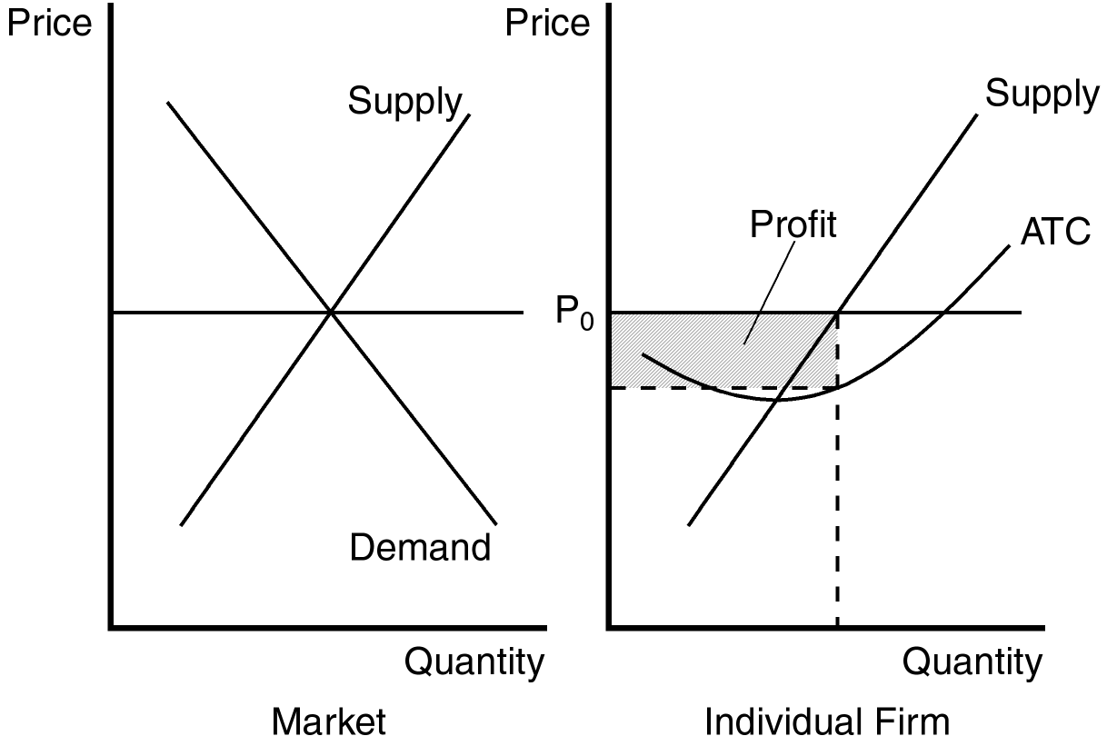

TYPE: S DIFFICULTY: 2 SECTION: 14.2
5. Explain how a firm in a competitive market identifies the profit-maximizing level of production. When should the firm raise production, and when should the firm lower production?
ANSWER: by selecting the level of output at which marginal revenue is equal to marginal cost. If MR > MC, profit will increase if the firm increases Q. If MR < MC, profit will increase if the firm decreases Q.
TYPE: S DIFFICULTY: 2 SECTION: 14.2
6. News reports from the western United States occasionally report incidents of cattle ranchers slaughtering a large number of newborn calves and burying them in mass graves rather than transport them to markets. Assuming that this is rational behavior by profit-maximizing "firms," explain what economic factors may influence such behavior.
ANSWER: If the selling price is not sufficient to cover the variable cost of sending them to market this behavior would make sense.
TYPE: S DIFFICULTY: 2 SECTION: 14.2
7. Use a graph to demonstrate the circumstances that would prevail in a perfectly competitive market where firms are experiencing economic losses. Identify costs, revenue, and the economic losses on your graph. Using your graph, determine whether this firm will shut down in the short run, or choose to remain in the market. Explain your answer.
ANSWER: The loss and revenue are identified on the individual firm’s graph. Total cost is equal to the sum of the losses and revenue. The decision about whether this firm shuts down or remains in the market depends upon the position of average variable cost. If average variable cost is below P0 at output level Q0, the firm will remain in the market. If average variable cost is above P0 at output level Q0 the firm will shut down in the short run.

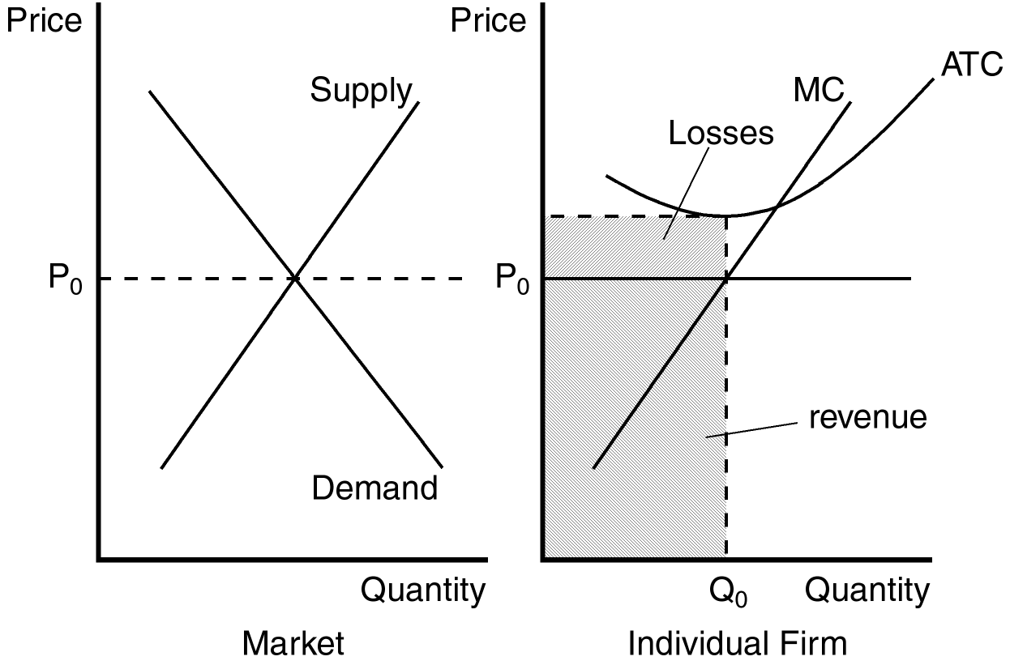

TYPE: S DIFFICULTY: 2 SECTION: 14.2
8. At its current level of production a profit-maximizing firm in a competitive market receives $12.50 for each unit it produces, and faces an average total cost of $10. At the market price of $12.50 per unit, the firm’s marginal cost curve crosses the marginal revenue curve at an output level of 1000 units. What is the firm’s current profit? What is likely to occur in this market and why?
ANSWER: $2,500; firms are likely to enter this market since existing firms are earning economic profits.
TYPE: S DIFFICULTY: 2 SECTION: 14.2
9. Give two reasons why the long-run industry supply curve may slope upward. Use an example to demonstrate your reasons.
ANSWER: Some resource used in production may be available only in limited quantities and firms may have different cost structures. The example provided in the text for the first reason is the market for farm products. As more people become farmers, the price of land is bid up since its supply is limited. As the price of farm land is bid up, the cost of all farmers in the market rises. The example used to support the second reason is the market for painters. Anyone can enter the market for painting services, but not everyone has the same costs because some painters work faster than others.
TYPE: S DIFFICULTY: 3 SECTION: 14.3
10. If identical firms that remain in a competitive market over the long run make zero economic profit, why do these firms choose to remain in the market?
ANSWER: because a normal rate of return on their investment is included as part of the opportunity cost of production.
TYPE: S DIFFICULTY: 2 SECTION: 14.3

